1. Funnel Chart – Sales Conversion
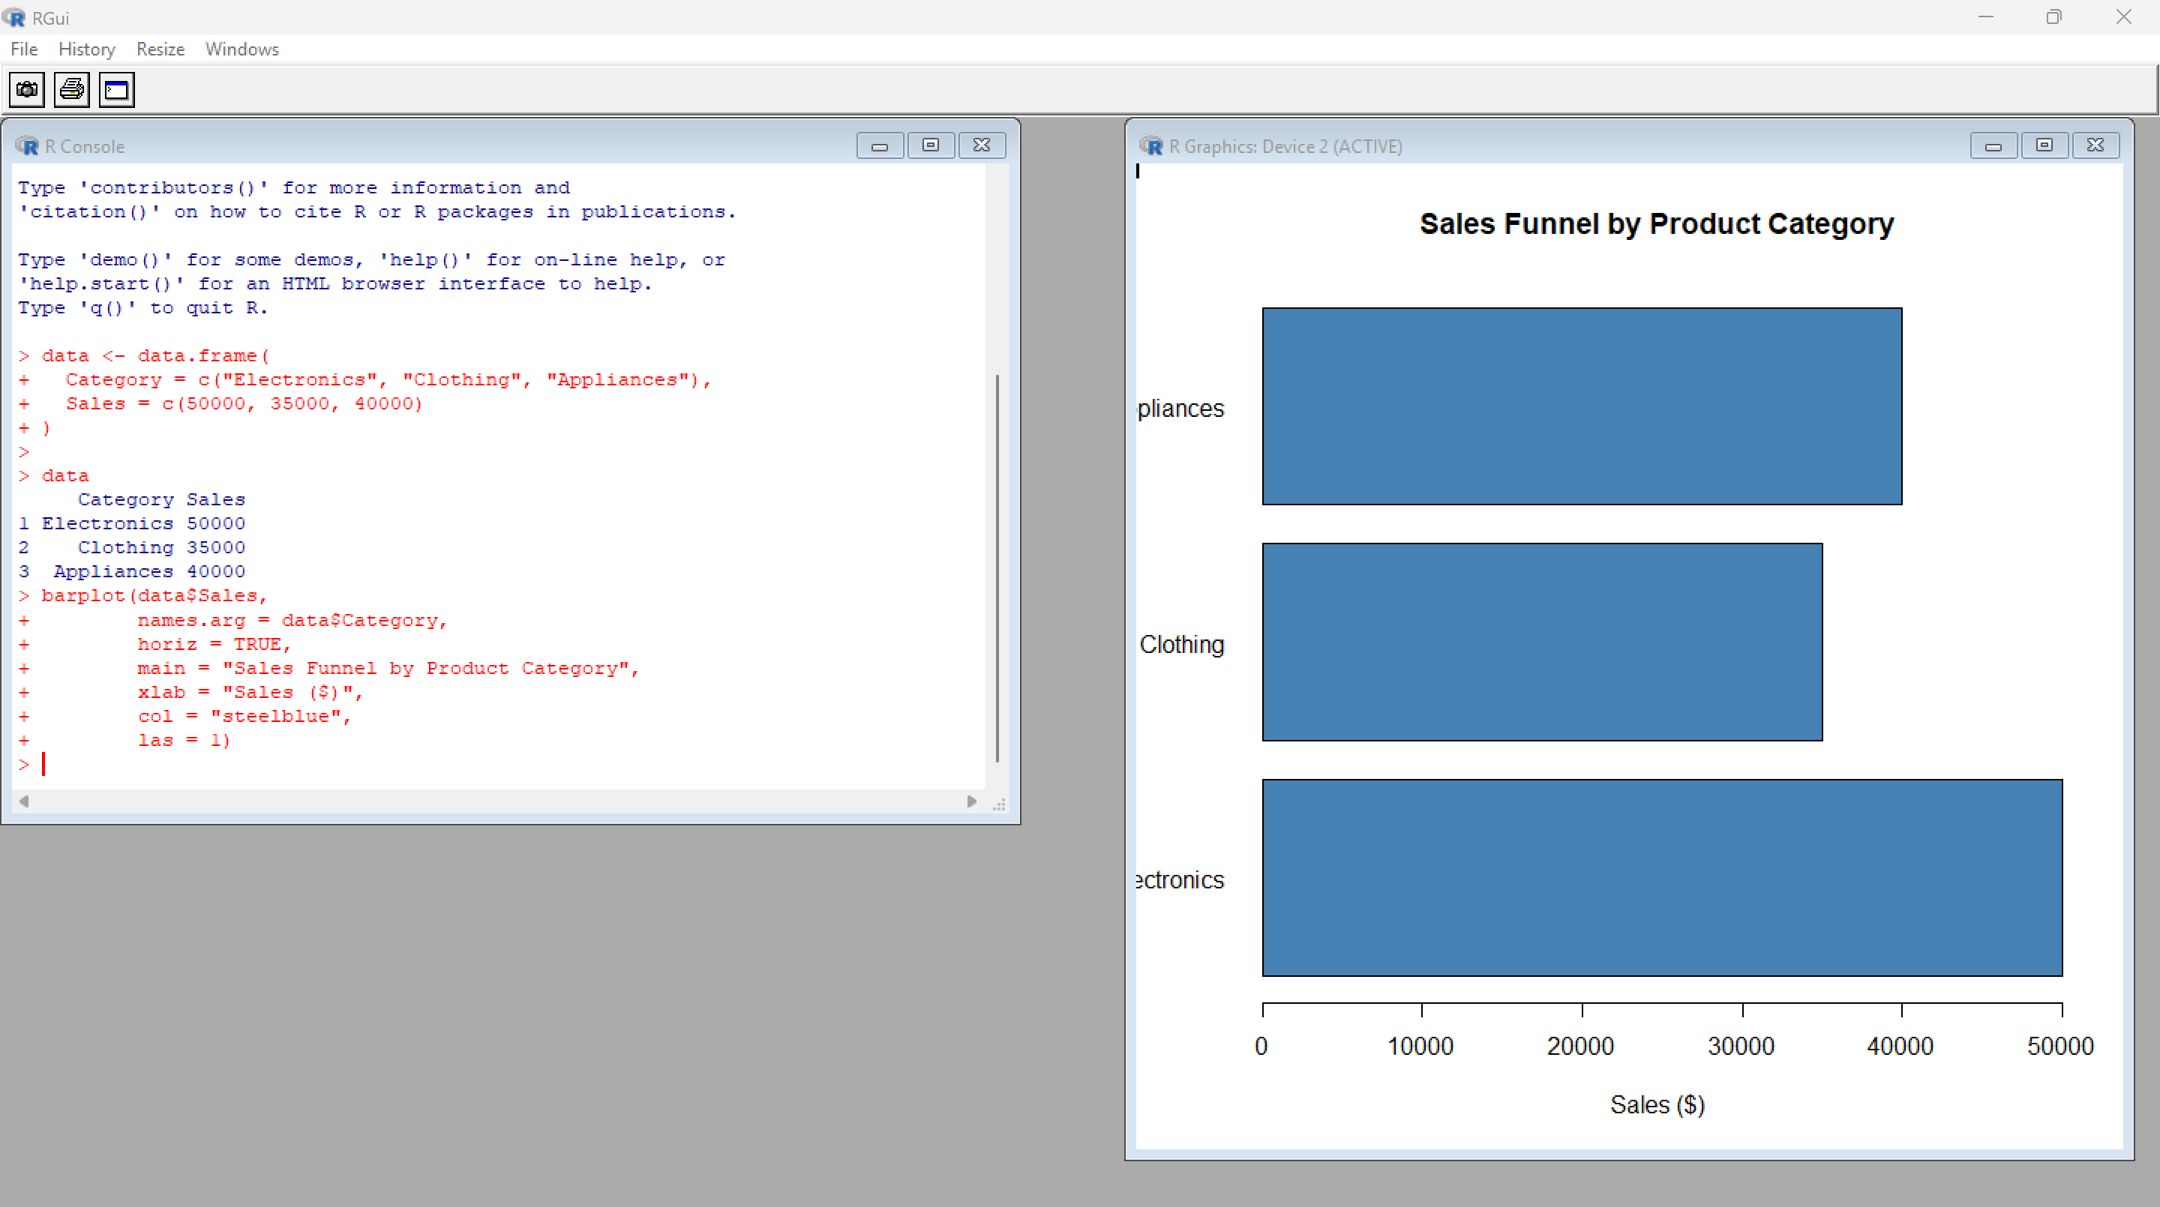
2. Table – Sales Data
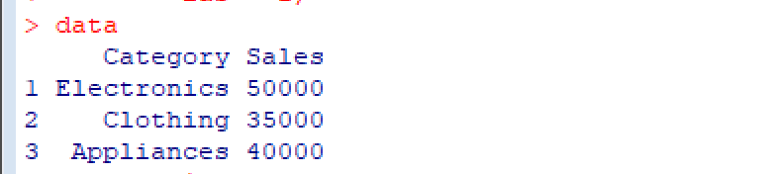

3.Tableu Dashboard
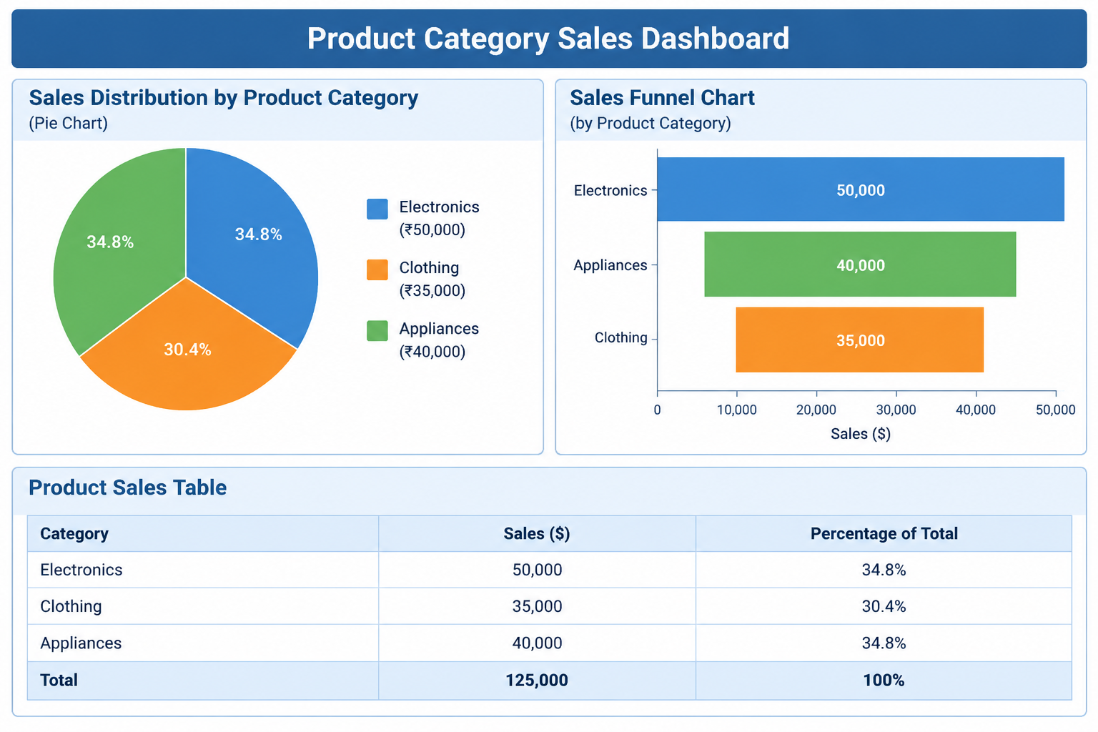
4. Pie Chart – Sales Distribution
